**Java Tasks**

**R Pradeep Kumar**

1. **Program to print numbers in reverse order**

Program:

class whileloop{

public static void main(String[] args){

int i=10;

while(i>=1){

System.out.println(i);

i--;

}

}

}

Output:

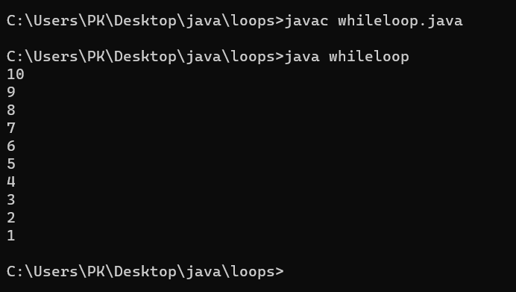

1. **Program that prompt the user to input an integer and it should print multiplication table of that number.**

Program:

import java.util.*;

class forloop{

public static void main(String[] args){

Scanner sc = new Scanner(System.in);

int i,a,j;

System.out.println("Enter a number : ");

a=sc.nextInt();

System.out.println("The multiplication table for "+a + " is :");

for(i=0;i<=10;i++){

j=i*a;

System.out.println(i+"*"+a+" = "+j);

}

}

}

Output:

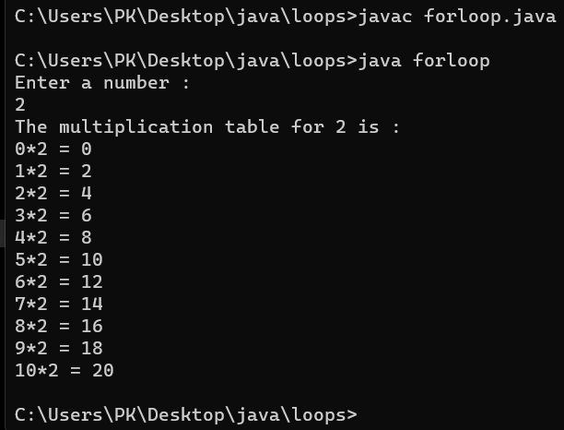

1. **Write a do-while loop that asks the user to enter 2 numbers and displays its sum , and asks if he wants to continue or not**

Program:

import java.util.*;

class dowhile{

public static void main(String[] args){

Scanner sc = new Scanner(System.in);

int a,b,c,ch;

do{

System.out.println("Enter value for a :");

a=sc.nextInt();

System.out.println("Enter value for b : ");

b=sc.nextInt();

c=a+b;

System.out.println("The answer is "+c);

System.out.println();

System.out.println("Do you want to continue ? Type 1 for Yes or 0 for No");

ch = sc.nextInt();

}while(ch!=0);

}

}

Output:

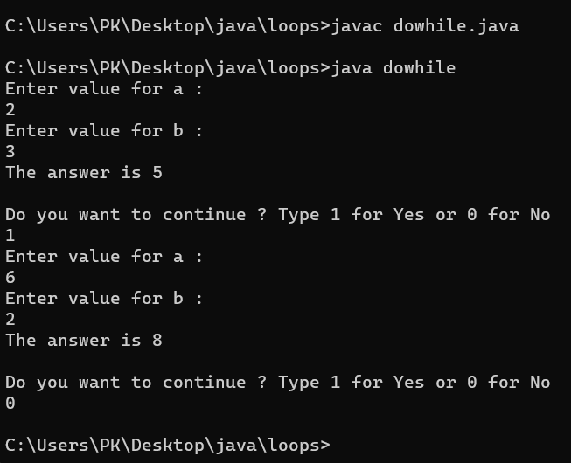

1. **Program that counts the number of +ve and –ve numbers the user has entered**

Program:

import java.util.*;

public class countnumbers {

public static void main(String[] args) {

Scanner sc = new Scanner(System.in);

int countPositive = 0;

int countNegative = 0;

System.out.println("Enter a sequence of numbers (enter 0 to stop):");

while (true) {

int number = sc.nextInt();

if (number == 0) {

break;

} else if (number > 0) {

countPositive++;

} else {

countNegative++;

}

}

System.out.println("Count of positive numbers: " + countPositive);

System.out.println("Count of negative numbers: " + countNegative);

}

}

Output:

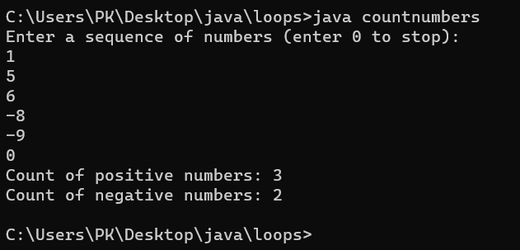

1. **Program to print triangle and pyramid patterns**

Program:

class pattern{

public static void main(String[] args){

int i,j,k,l,m,n=5;

System.out.println("This is a pyramid : ");

for(i=0;i<n;i++){

for(j=0;j<=i;j++){

System.out.print("*");

}

System.out.println(" ");

}

System.out.println();

System.out.println("This is a Triangle :");

for(k=0;k<n;k++){

for(l=n-k;l>0;l--)

System.out.print(" ");

for(m=0;m<=k;m++)

System.out.print("* ");

System.out.println();

}

}

}

Output:

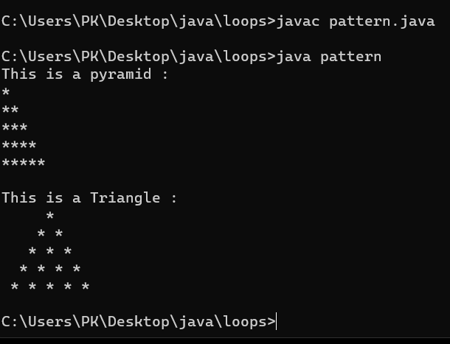

1. **Program to implement calculator**

Program:

import java.util.*;

class calci{

public static void main(String[] args){

Scanner sc = new Scanner(System.in);

double a,b,c;

String ch;

System.out.println("Enter the value of a : ");

a=sc.nextDouble();

System.out.println("Enter the value of b : ");

b=sc.nextDouble();

System.out.println("Enter the operation you need to perform ");

System.out.println("Enter + for Addition ");

System.out.println("Enter - for Subtraction ");

System.out.println("Enter * for Multiplication ");

System.out.println("Enter / for Division ");

System.out.println("Enter % for Modulus ");

ch=sc.next();

switch(ch){

case("+"):

c=a+b;

System.out.println("Answer is "+c);

break;

case("-"):

c=a-b;

System.out.println("Answer is "+c);

break;

case("*"):

c=a*b;

System.out.println("Answer is "+c);

break;

case("/"):

c=a/b;

System.out.println("Answer is "+c);

break;

case("%"):

c=a%b;

System.out.println("Answer is "+c);

break;

default:

System.out.println("Enter valid choice ");

break;

}

}

}

Output:

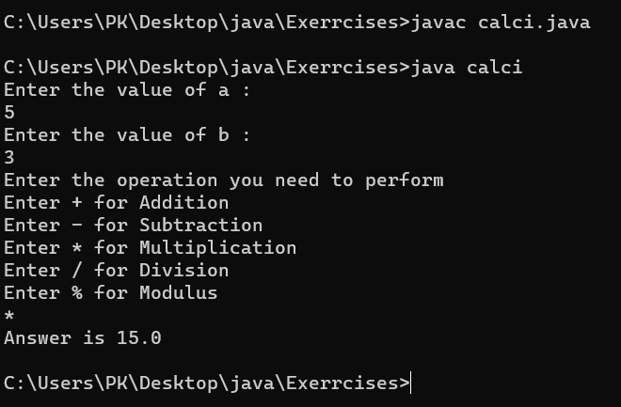

1. **Program to find leap year or not**

Program:

import java.util.*;

class leap{

public static void main(String[] args){

Scanner sc = new Scanner(System.in);

int a ;

System.out.println("Enter the year : ");

a=sc.nextInt();

if(a%400==0 ||(a%4==0 && a%100 !=0) ){

System.out.println("It is a leap year ");

}else

System.out.println("It is not a leap year ");

}

}

Output:

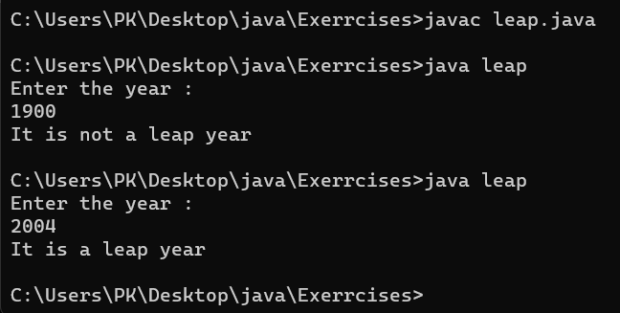

1. **Program to find entered number is odd or even**

Program:

import java.util.*;

class odd{

public static void main(String[] args){

Scanner sc = new Scanner(System.in);

double a;

System.out.println("Enter a number: ");

a=sc.nextDouble();

if(a%2==0){

System.out.println("It is a even number ");

}else{

System.out.println("It is a odd number ");

}

}

}

Output:

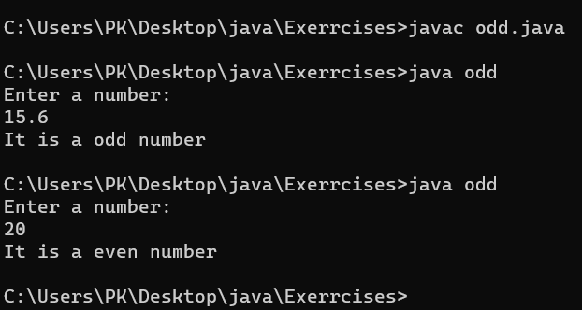

1. **Program to swap 2 numbers without using temporary variable**

Program:

import java.util.*;

class swap{

public static void main(String[] args){

Scanner sc = new Scanner(System.in);

int a,b;

System.out.println("Enter value of a : ");

a=sc.nextInt();

System.out.println("Enter value of b : ");

b=sc.nextInt();

System.out.println("Value of a and b before swappig is : a= " +a + " b= " +b);

a=a+b;

b=a-b;

a=a-b;

System.out.println("Value after Swapping is : a= " +a + " b= " +b);

}

}

Output:

